# MGT1022- Lean Start-up Management

**DIGITAL ASSIGNMENT-1**

**ALOKAM NIKHITHA (19BCE2555)**

**Summary on Lean start-up by Eric Ries**

The Lean Startup is taking hold in new and established businesses to help entrepreneurs and managers do one important thing: make better business decisions, faster. Much better and faster business decisions. Bringing the principles of lean manufacturing and agile development to the innovation process, Lean Startup helps companies succeed in a risk-filled business landscape.

Eric Ries is the author of the popular Startup Lessons Learned blog and the creator of the Lean Startup methodology. He co-founded and served as CTO of IMVU, his third startup, which today has over 40 million users and 2009 revenue of over $22 million.An entrepreneur-in-residence at Harvard Business School and a frequent speaker at corporate events, he advises startups on business and product strategies using the Lean Startup approach.

Lean Startup is about learning what your customers really want and learning it fast. It's about constantly testing what you think your customers might want and adjusting based on the results, and doing it before you run out of money.

From the book Lean start up management by Eric Ries We can learn five critical Lean Startup principles:

**1. Entrepreneurs are Everywhere**

Entrepreneurs exist not only in industries, but also in large corporations and government organizations. Regardless of industry, size of business, or your role, entrepreneurs are everywhere. You donot necessarily want to be the founder to apply entrepreneurship. In large organizations, it is up to leadership to create an environment that allows entrepreneurship and experimentation to thrive.

**2. Entrepreneurship is management**

Although different from traditional management like what you might learn with an MBA, entrepreneurship is still management in which the management approach must be tailored to the specific needs of a startup, i.e. an environment of extreme uncertainty. A startup is an institution that must manage.

**3. Validated learning**

Your startup's job is to learn what your customers want so you can build a sustainable business. Conduct this learning as scientifically as possible. Startups exist not only to create a product and make money, but also to learn how to create a sustainable business. This is done by using frequent experimentation and testing to arrive at a vision.

**4. Build-Measure-Learn**

This loop is the essential activity of a startup. Iterating thru this loop facilitates you research. The quicker you iterate thru it, the quicker you’ll research and make progress. The essential hobby of a startup is to show thoughts into products, degree how clients reply after which research whether or not to pivot or persevere.

**5. Innovation Accounting**

Startups want to cognizance on measuring development in the direction of dreams and prioritise work. This calls for a brand new sort of accounting designed for startups.Gives us the gear to degree if our startup is making development.

This book is organized into 3 key parts. In ‘Vision’ the book defines how an entrepreneur and startup sincerely are and articulates a brand new manner for startups to degree of their development called ‘validated learning’. ‘Steer’ dives into the method of the build-measure-learn feedback loop. And in ‘Accelerate’ the book explores strategies to hurry up the ‘Steer’ process and increase methods.

**Part-1. VISION**

Vision is defined as the approach or the way to get there (modified by a pivot or persevere) and the product defines the approach (and is continuously optimised). The Lean Startup model is designed to educate you the way to drive a startup. Instead of creating complicated plans which are primarily based totally on a number of assumptions, you could make steady adjustment with a steering wheel referred to as the build-measure-learn feedback loop.

Entrepreneurs are everywhere. They’re in big mounted firms as nicely as small startups. A startup is a human organization designed to create a brand new product or service below situations of excessive uncertainty. This definition has not anything to do with the size of the organization or the industry you’re working in.

If the fundamental aim of entrepreneurship is to interact in business enterprise building beneathneath situations of severe uncertainty, its maximum essential feature is getting to know. We ought to analyze the reality approximately which factors of our approach are operating to realise our vision and which might be simply crazy. Validated getting to know is the procedure of demonstrating empirically that a group has found precious truths approximately a startup’s gift and destiny business prospects.

The Lean Startup technique reconceives a startup’s efforts as experiments that check its approach to peer what works. A authentic test follows the scientific technique. It starts with a clear hypothesis that makes predictions approximately what is alleged to happen. It then tests the ones predictions empirically. The cost hypothesis tests whether or not a services or products certainly provides cost to clients as soon as they're the use of it.

**Part-2.STEER**

As we noticed in Part One, the products in startup builds are actually experiments; the studying approximately a way to construct a sustainable enterprise is the final results of those experiments. For startups, that records is a great deal greater essential than dollars, awards, or mentions withinside the press, due to the fact it is able to influence and reshape the following set of ideas.

The goal of your startup with the Lean Startup is to analyze. To analyze as rapid as viable what your clients need and what is going to create a sustainable business. This studying is achieved the use of disciplined experiments. These disciplined experiments are achieved the use of the Build-Measure-Learn comments loop.

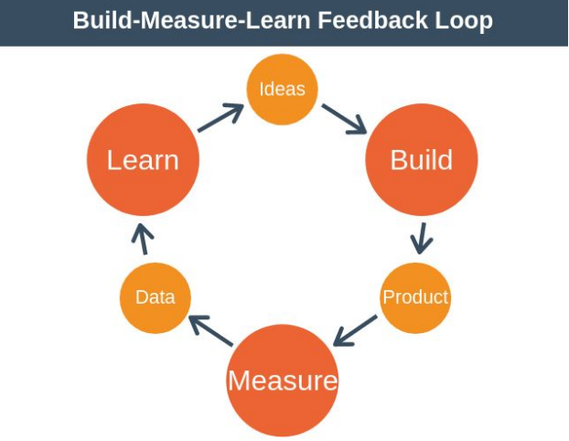

I name the riskiest factors of a startup’s plan, the elements on which everything depends, leap-of-religion assumptions. The most crucial assumptions are the value hypothesis and the growth hypothesis. These supply upward push to tuning variables that manage a startup’s engine of growth. Each new release of a startup is an try to rev this engine to look if it'll turn. Once it is running, the process repeats, transferring into better and better gears.

**The Value hypothesis:**

The first step in expertise a brand new products or services is to determine out if it's miles essentially cost-growing or cost-destroying.

**The Growth Hypothesis:**

A comparable factor is real for boom. As with cost, it’s vital that marketers apprehend the motives in the back of a startup’s growth.

Once clear on those leap-of-religion assumptions, step one is to go into the Build section as speedy as viable with a minimal possible product (MVP). The MVP is that model of the product that allows a complete flip of the Build-Measure.

Learn loop with a minimal quantity of attempt and the least quantity of improvement time. The minimal possible product lacks many functions that may show important later on.

A minimal possible product (MVP) enables entrepreneurs begin the technique of gaining knowledge of as speedy as viable. It isn't always always the smallest product imaginable, though; it's far truly the quickest manner to get through the Build-Measure-Learn comments loop with the minimal quantity of attempt.

**Measure actionable metrics.**

1) **Actionable:** they display purpose and have an effect on

2) **Accessible:** may be understood through everyone. Each cohort evaluation says: most of the folks that used our product on this period, here’s how lots of them exhibited every of the behaviors we care approximately

3) **Auditable:** We have to make certain that the statistics is credible to employees.

**The Pivot**

In Lean Startup, a pivot way to alternate path however to stay grounded in what you've got got learned.

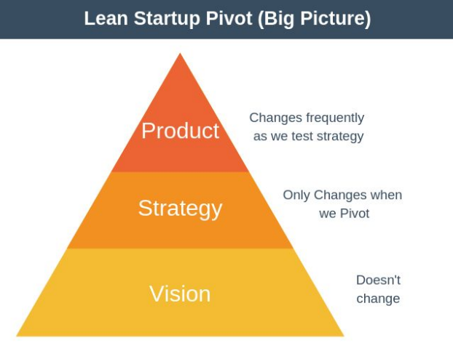

To construct a thriving commercial enterprise, you may want a clean imaginative and prescient. You additionally want a method to recognise your imaginative and prescient, inclusive of commercial enterprise model, product plan, and customers. Changing your method is referred to as a pivot however that does not imply your imaginative and prescient changes

Types of Pivot There are many not unusualplace styles of pivot, including:

**1. Zoom-In Pivot** : Users virtually like a selected characteristic of your product. You determine to cognizance completely on this characteristic and drop all of the others.

**2. Zoom-Out Pivot** : Your functions are not sufficient on their very own for customers, so that you upload extra.

**3. Customer Segment Pivot** : Your product is great, however it is fixing a hassle for the incorrect organization of users. You determine to pivot to a brand new goal audience.

**4. Customer Need Pivot** : You've hung out knowledge your customers, however the product you've got constructed would not resolve a sizeable hassle they have. You pivot to deal with a extra vital hassle for the equal customers.

**5. Platform Pivot** : A platform pivot entails converting from an utility right into a platform or vice versa.

**6. Business Architecture Pivot** : Here you pivot from a excessive margin and occasional quantity income method to a low margin and excessive quantity method or vice versa.

**7. Value Capture Pivot:** In this pivot, you convert the manner you monetize your product. For example, you would possibly pass from an marketing and marketing version to a subscription version.

**8. Engine of Growth Pivot**: In this pivot, you convert the manner you entice customers. For example, you could pass from an natural version to a paid version.

**9. Channel Pivot** : A channel pivot entails converting the way you supply your product on your customers. For example, you may pivot from promoting without delay to promoting thru third-celebration distributors.

**10. Technology Pivot** : A generation pivot occurs whilst a enterprise discovers the way to supply the equal answer thru a exceptional generation, normally to shop costs. For example, Netflix switched from presenting CDs thru the mail to turning in films totally over the internet.

**Part-3.ACCELERATE**

**Batch**

The small-batch technique produces a completed product each few seconds, while the large-batch technique ought to supply all the goods at once, at the end. The largest gain of running in small batches is that first-rate issues can be diagnosed tons sooner. Toyota observed that small batches made their factories extra efficient. In contrast, withinside the Lean Startup the purpose isn't to supply extra stuff efficiently. It is to—as quick as possible—discover ways to construct a sustainable business.

There are 4 primary methods beyond customers drive sustainable growth:

1) Word of mouth,

2) as a side impact of product use, e.g. luxurious items and standing symbols,

3) Through funded marketing and marketing and

4) Through repeat buy or use. These sources of sustainable growth strength feedback loops that I actually have termed engines of boom. Each is sort of a combustion engine, turning over and over. The quicker the loop turns, the quicker the employer will grow.

**The sticky engine of increase** – Companies the usage of the sticky engine of increase tune their attrition fee or churn fee very carefully. The churn fee is described as the fraction of clients in any duration who fail to stay engaged with the corporation’s product. The regulations that govern the sticky engine of increase are pretty simple: if the fee of recent patron acquisition exceeds the churn fee, the product will develop

**The viral engine of increase** – Awareness of the product spreads swiftly from individual to individual in addition to the manner a deadly disease will become an epidemic. Like the different engines of increase, the viral engine is powered through a comments loop that can be quantified. It is referred to as the viral loop, and its pace is decided through a single mathematical time period referred to as the viral coefficient

**The paid engine of increase** – As the call suggests, this engine of increase is depending on paying to accumulate clients. If both corporation desires to increase its fee of increase, it is able to accomplish that in certainly considered one among ways: boom the sales from every patron or pressure down the fee of obtaining a brand new client. Like the different engines, the paid engine of increase is powered through a comments loop. Each client can pay a sure amount of cash for the product over his or her “lifetime” as a client.

**Innovate**

In order to be successful, innovation teams must be properly structured.

Resources are few but secure – In contrast to a huge corporation, where a department may have 10% reallocated in an emergency, a stand-alone startup firm losing 10% of its cash on hand is highly rare.

As a result, startups are both easier and more difficult to manage than classic divisions: they require significantly less cash overall, but that capital must be completely safe against tampering.

# Plagarism Report

# First 2 pages content

# 

# Next 2 pages content

# 

# Last page content;

# 